OFS Alert Store API

The OFSX Alert Store API allows programmatic inspection of alerts and forms that have been raised on an OFS server. This document provides an overview of querying the OFS Alert Store API

API Requests
The OFS API is accessed using HTTP GET / POST via TCP using TLS on port 443. Results are UTF-8 JSON objects unless otherwise specified.

Encoding Credentials
OFS server access requires standard HTTP Basic Authentication.
Users will only be able to access the OFS Alert Store API if they have alertread permission.

OFS Alert Store API URL
The OFS Alert Store API is accessible at:

https://{yourofsserver}/alertstore/query?limit=1

URL query parameters
Query parameters must be properly URL Encoded:

Parameter | Description
Filter | a JSON filter definition for the query (described below).  All timestamps are UTC unix millisecond timestamps. Each part of the filter is optional.  {  "createTime": { // filter by create time of alert  "from": xxxxxxxx,  "to": yyyyyyyy  }, "dismissTime": { // filter by dismiss time  "from": xxxxxxxx,  "to": yyyyyyyy,  },  "dismissed": true || false, //  true = return only dismissed,  // false = return non-dismissed  "ID": [ // filter by internal alert id  "alertid",  ...  ],  configUID: [ // filter by alertconfig uid  // (shown as api key in UI. Requires server  "Uid", // shard key. Format: xxxx:abcd-1234-efgh  ...  ],  GID: [ // if present, filter by alertgroup  "gid",  ...  ],  "workcentre": [ // filter by OFS workcentre ID  "line",  ...  ],  "workflow": "workflowName", // filter by the given workflow  "workstate": [ // if present, filter by workstate  "state",  ....  ],  "eventChart": true || false // true to constrain to only alerts  // that are displayed on the event  // chart.  // false or absent for all alerts  }
terse | return a terse (or abbreviated) version of the alerts
limit | return only the most recent n alerts by create time matching the filter conditions.  YOU SHOULD AVOID A QUERY WITH NO FILTER or limit.. it will return all alerts.
beforeTS | only return alerts created before this UTC unix millisecond timestamp (used internally for paging)
hardlimit | if there are more than this number of alerts that match the filter, fail with an error message

Response
The response will be a JSON object with the following forms:

On success, a 200 HTTP return with a set of alerts matching the filter (see below for a full example) :
{
"alertset": [
…
],
"setlength": n,
"status": "ok",
"tag": ""
}

On failure a non-200 HTTP status code (depending on failure) with a JSON body:
{
"errorData": "reason for failure",
"status": "error"
}

Example

Query: https://demo.ofslive.com/Alert Store/query?limit=1

Response contains a detailed json alert object, including the full line context when the alert was triggered. Contact OFS Support for advice on accessing information from this data structure:

{
"alertset": [
{
"alertconfig": {
"form": {
"fields": [
{
"defaultValue": "no",
"fieldType": "checkbox",
"help": "All debris, foreign material and loose items created or used during setup have been removed from machine",
"name": "Foreign Material Check",
"noValue": "no",
"required": false,
"title": "",
"unit": "",
"yesValue": "yes"
},
{
"defaultValue": "no",
"fieldType": "checkbox",
"help": "Product contact zones have been cleaned and sanitised where maintenance work was performed",
"name": "Contact Zone Check",
"noValue": "no",
"required": false,
"title": "",
"unit": "",
"yesValue": "yes"
}
]
},
"no_event_chart": false,
"template": "",
"title": "New Alert",
"type": "flow",
"uid": "fd721fab-3087-45b2-a0ed-1b1f116290f5",
"version": 6
},
"auditlog": [
{
"changeset": [
{
"from": "",
"to": "",
"what": "create"
}
],
"timestamp": 1546839979966,
"user": "sewriter"
},
{
"changeset": [
{
"from": "0",
"to": "1546840020119",
"what": "dismissTime"
},
{
"from": "1546839960000",
"to": "1546840020119",
"what": "lastStateChange"
},
{
"from": "Pending",
"to": "Delayed",
"what": "workstate"
}
],
"timestamp": 1546840020119,
"user": "OFS-X System"
}
],
"createTime": 1546839960000,
"data": {
"Contact Zone Check": "no",
"Foreign Material Check": "no"
},
"dismissTime": 1546840020119,
"id": "cccc0000-0000-0000-0000-000000018344",
"lastStateChange": 1546840020119,
"message": "",
"state": {
"trigger": {
"match": "periodic",
"matchCount": 1,
"span": {},
"title": "periodic weekly",
"units": "minutes",
"value": 0
},
"workcentre": {
"machineState": {},
"spans": {
"relay01": {
"counts": {
"out": 13191948,
"out.raw": 13191948,
"out.raw.unadjusted": 13191948,
"out.unadjusted": 13191948,
"rated": 595728,
"rated.unadjusted": 595728,
"through": 13195257,
"through.unadjusted": 13195257
},
"end": 0,
"id": 9352,
"name": "relay01",
"spanClass": "Case Packer",
"spanType": "relay01",
"start": 1543535400780,
"type": "R"
}
},
"timestamp": 1546839960000,
"timestampText": "2019-01-07 16:46:00.000",
"totalMetrics": {
"ava": 0.4997911350340649,
"capitalTime": 47835979837,
"counts": {
"out": 105495486,
"out.raw": 107054932,
"out.raw.unadjusted": 107054932,
"out.unadjusted": 107054868,
"rated": 107033647,
"rated.unadjusted": 107030580,
"through": 110085362,
"through.unadjusted": 110354027
},
"end": 1546839979837,
"endText": "2019-01-07 16:46:19.837",
"jobEvents": 287,
"oee": 0.4734199392106187,
"openTime": 33798655358,
"openUnitsIn": 110085103,
"pe": 0.9884476981336533,
"plannedDowntime": 99912194,
"plannedDowntimeEvents": 14,
"productionTime": 26433381516,
"productionUnitsIn": 106814517,
"quality": 0.9583062096848081,
"runEvents": 395,
"runFastEvents": 3,
"runFastTime": 163593969,
"runSlowEvents": 70,
"runSlowTime": 588564350,
"runTime": 16892268324,
"runUnitsIn": 105797162,
"setupEvents": 279,
"setupTime": 7365273842,
"setupUnitsIn": 3270586,
"shiftEvents": 251,
"shiftTime": 33898567552,
"shortStopEvents": 222,
"shortStopTime": 3599819,
"start": 1499004000000,
"startText": "2017-07-03 00:00:00.000",
"unitsIn": 110085362,
"unitsNamePlate": 112615122,
"unitsOut": 105495486,
"unitsRated": 107033647,
"unplannedDowntime": 9541113192,
"unplannedDowntimeEvents": 465,
"unplannedSetupDowntime": 1507965703,
"unplannedSetupDowntimeEvents": 18,
"validSince": 1544952968167,
"validSinceText": "2018-12-16 20:36:08.167"
},
"workcentre": {
"class": "workcentre",
"console": "OFSTESTLINE065",
"consoletime": 1546839979942,
"consoletimeText": "2019-01-07 16:46:19.942",
"consoletimezone": "Australia/Melbourne",
"id": 1,
"name": "Test Line 065",
"systemtimeText": "2019-01-07 16:46:19.942",
"systemtimezone": "Australia/Melbourne",
"title": "Test Line 065",
"uptime": 1887022329
}
}
},
"workcentre": "OFSTESTLINE065",
"workflow": "Shift Start Work Flow",
"workstate": "Delayed",
"workstatelog": [
{
"endTime": 1546840020119,
"startTime": 1546839960000,
"workstate": "Pending"
},
{
"endTime": 0,
"startTime": 1546840020119,
"workstate": "Delayed"
}
]
}
],
"setlength": 1,
"status": "ok",
"tag": ""
}

Flow APIs and Power BI

The API can have browser parameters, one being the filter and the other a limit:
- A filter is used to filter down the results by workcentre, workflow, workstate, alert ID, create time and more.
- A limit just limits the maximum number of forms the API call can retrieve.

Step 1: Creating a base URL
Template: https://{yourofsserver}/alertstore/query?limit=50
- Replace {yourofsserver} with the customer’s OFS URL
- Specify a limit for the number of Flow Forms to bring in, e.g. limit=50
  - We always INSIST you have a filter, and if you do not have a filte,r you MUST specify a limit. If you do not have a filter or a limit, every alert that has ever fired will be retrieved with each call, and it will likely cause instability in the software.

Example 1: https://customer.ofsxpress.com/alertstore/query?limit=50

Example 2: on-premise Customer Example: https://10.123.45.678/alertstore/query?limit=1

Step 2: Creating the confidUID
- The configUID combines the shard key + the API export key
  - Format: xxxx:abcd-1234-efgh
  - xxxx = shard key
    - The shard key is found in Advanced settings > Organisations > Alerts Shard Key.
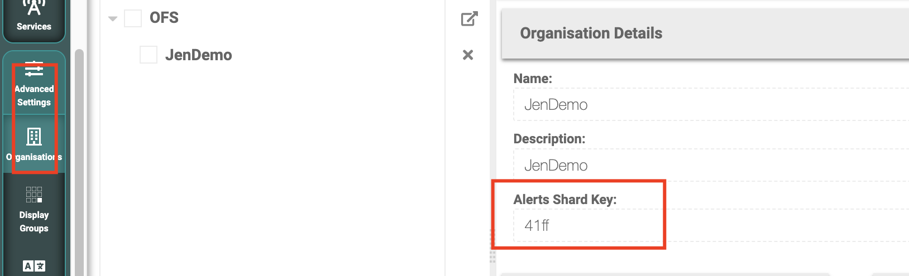
  - abcd-1234-efgh = API export key for the individual alert
    - Found in each individual Alert
  - Example: 41ff:979857cf-6db8-4b52-a076-1263acefe5fa

Step 3: Creating the Filters as a JSON
Example: Filter by workcentre ID and create time
- configUID
- "configUID":["xxxx:abcd-1234-efgh"]
- Example: "configUID":["41ff:0218e343-d7b2-45d2-bf7b-e9bcf243a6e4"]
- Workcentre ID filter
- "workcentre":["WorkcentreID"]
- Example: "workcentre":["OFSTESTLINE100"]
- Create Time filter
- "createTime":{"from":0000000000000,"to":0000000000000}
- The Create time filters use epoch timestamp in milliseconds
  - Note: Epoch is the time since 1 Jan 1970
- Use the website https://www.epochconverter.com/ to convert the epoch time to local time.
  - Note: In PowerBI, you could convert the time automatically using coding
  - Beware of using this for different timezones to you
  - Example:
  - From: 1 Oct 2023 = 1696082400000
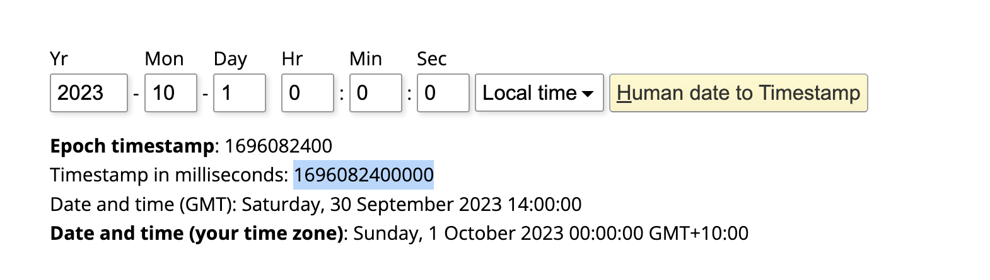
  - To: 30 Oct 2023 = 1698584400000

Step 4: Converting the JSON to be URL encoded
- Filter in JSON = {"workcentre":["OFSTESTLINE100"],"createTime":{"from":1696082400000,"to":1698584400000},"configUID":["41ff:979857cf-6db8-4b52-a076-1263acefe5fa"]}
  - Ensure there is a { at the start of the string and a } at the end of the string.
- Converting to URL encoded
  - Note: all filters must be a URL-encoded JSON string.
  - This website will convert it for you: https://www.urlencoder.io/
Example: %7B%22workcentre%22%3A%5B%22OFSTESTLINE100%22%5D%2C%22createTime%22%3A%7B%22from%22%3A1696082400000%2C%22to%22%3A1698584400000%7D%7D

Step 5: Create the API Export URL by combining the base URL and Filter (URL encoded)
- Insert the base URL
- Specify the filter browser parameter: &filter=
- This is only because limit=50 is at the start. If no limit filter then the browser parameter is directly after “query?”
- Insert the URL-encoded JSON filters
- Test this URL in the web browser
Final API Export URL Example:
https://customer.ofsxpress.com/alertstore/query?limit=50&filter=%7B%22workcentre%22%3A%5B%22OFSTESTLINE100%22%5D%2C%22createTime%22%3A%7B%22from%22%3A1696082400000%2C%22to%22%3A1698584400000%7D%7D

Exporting OFS-Flow APIs to Power BI

We are unable to directly help with Power BI as we do not use it in our business. We suggest that you will need to reach out to a Power BI expert if you have any further questions on Power BI directly.

However, to import this data into Power BI, you will need to use a Web Import with Basic Authentication. Once you craft your export URL, you will need to enter this and authenticate with your OFS login.

Importing data:
Step 1 - Click ‘Get Data’
Step 2 - Click ‘Web’
Step 3 - Enter the base URL
Step 4 - Click Basic and enter your OFS login credentials
Step 5 - Apply changes

Template: How Do I Create an OFS-Flow API?

Step 1: Creating a base URL
Template: https://{yourofsserver}/alertstore/query?limit=50

URL:

Step 2: Creating the confidUID
  - Shard Key : API Export Key
  - Format: xxxx:abcd-1234-efgh

Step 3: Creating the Filters
- configUID
- "configUID":["xxxx:abcd-1234-efgh"]}
- "configUID":[" "]}
- Workcentre ID filter
- {"workcentre":["WorkcentreID"]
- {"workcentre":["OFSTESTLINE100"]
- Create Time filter
- "createTime":{"from":0000000000000,"to":0000000000000}
  - From: 1 Oct 2023 = 1696082400000
  - To: 30 Oct 2023 = 1698584400000

Step 4: Combing the filters to JSON format
- Filter in JSON =

Step 5: Converting the JSON to URL encoded
- This website will convert it for you: https://www.urlencoder.io/
Example:

Step 6: Create the API Export URL by combining the base URL and Filter (URL encoded)
- Insert the base URL
- Specify the filter browser parameter: &filter=
- Insert the URL-encoded JSON filters
- Test this URL in the web browser
Final API Export URL:

